

Adult Safeguarding

Policy and Procedures

January 2026

Document Name | Adult Safeguarding Policy and Procedures
Document Type | Policy and Procedures
Owner | Stepney Bank Stables
Date of Revision | 7th January 2026
Date for Review | 31 January 2027
Details of Review | This Safeguarding Adults Policy and Procedure will be clearly communicated to staff, trustees, volunteers, and service users. The Designated Named Person will be responsible for ensuring that this is done.  The Safeguarding Adults Policy and Procedures will be reviewed annually by the Stepney Bank Stables Board of Trustees or following a serious incident. The Designated Named Person for Safeguarding Adults will be involved in this process and can recommend any changes. The Designated Named Person will also ensure that any changes are clearly communicated to staff, trustees and volunteers.
Associated Documents | Safeguarding Children and Young People Policy  Complaints Policy and Procedure  - Safer Recruitment Policy  - Equality and Diversity  - Data Protection  - Volunteering  - Staff Handbook  - Whistleblowing Policy  - Staff Code of Conduct  - Health and Safety Policy  - First Aid Procedure
Signed | Name_____________________________  Position___________________________  Signature__________________________  Date______________________________

Section A: Policy
Statement
This policy will enable Stepney Bank Stables to demonstrate its commitment to keeping safe adults at risk with whom it works alongside. Stepney Bank Stables acknowledges its duty to act appropriately to any allegations, reports or suspicions of abuse.

It is important to have the policy and procedures in place so that staff, volunteers, service users and carers, and trustees can work to prevent abuse and know what to do in the event of abuse and know what to do should a concern arise.

Purpose
This policy and associated procedures have been drawn up in order to enable Stepney Bank Stables to:

- Promote good practice and work in a way that can prevent harm, abuse and coercion occurring.

- To ensure that any allegations of abuse or suspicions are dealt with appropriately and the person experiencing abuse is supported, and

- To stop that abuse occurring.

  - Definition
Abuse is a violation of an individual’s human and civil rights by any other person or persons (DH, 2000).

Abuse may be:
- A single act or repeated acts
- An act of neglect or a failure to act
- Multiple acts, for example, an adult at risk may be neglected and also being financially abused.

The document should use the term ‘adult at risk’ in compliance with The Care Act 2014. This replaces the term Vulnerable Adult as used in No Secrets.

An adult at risk is defined by The Care Act 2014 as:

A person who
- Has needs for care and support (whether or not the authority is meeting any of those needs),

- Is experiencing, or at risk of, abuse or neglect, and

- As a result of those needs is unable to protect him or her against the abuse or neglect or the risk of it.

An adult at risk may therefore be a person who:

- Is elderly and frail due to ill health, physical disability or cognitive impairment
- Has a learning disability
- Has a physical disability and/or a sensory impairment
- Has mental health needs including dementia or a personality disorder
- Has a long-term illness/condition
- Misuses substances or alcohol
- Is a carer such as a family member/friend who provides personal assistance and care to adults and is subject to abuse
- Is unable to demonstrate the capacity to make a decision and is in need of care and support

1.2 Policy Application
The policy applies to all staff, including trustees, paid staff, volunteers, sessional workers, agency staff, students and anyone working on behalf of Stepney Bank Stables.

It is acknowledged that significant numbers of adults at risk are abused and it is important that Stepney bank Stables has a Safeguarding Adults Policy, a set of procedures to follow and puts in place preventative measures to try and reduce those numbers.

In order to implement the policy Stepney Bank Stables will work:

- To promote the freedom and dignity of the person who has or is experiencing abuse
- To promote the rights of all people to live free from abuse and coercion
- To ensure the safety and wellbeing of people who do not have the capacity to decide how they want to respond to abuse that they are experiencing
- To manage services in a way which promotes safety and prevents abuse
- Recruit staff and volunteers safely, ensuring all necessary checks are made
- Provide effective management for staff and volunteers through supervision, support and training

Stepney Bank Stables:

- Will ensure that all, trustees, staff, volunteers, service users, and carers/families are familiar with this policy and procedures

- Will work with other agencies within the framework of the Newcastle Safeguarding Adults Boards Policy and Procedures, issued under Care Act 2014 statutory guidance.

- Will act within its confidentiality policy and will usually gain permission from service users before sharing information about them with another agency.

- Will pass information to the relevant Local Authority when more than one person is at risk. For example: if the concern relates to a worker, volunteer or organisation who provides a service to adults at risk or children.

- Will inform service users that where a person is in danger, a child is at risk or a crime has been committed then a decision may be taken to pass information to another agency without the service user’s consent.

- Will make a referral to the relevant Local Authority as appropriate.

- Will endeavor to keep up to date with national developments relating to preventing abuse and welfare of adults.

- Will ensure that the Designated Named Person understands his/her responsibility to refer incidents of adult abuse to the relevant statutory agencies.

The Designated Named Person for Safeguarding Adults in Stepney Bank Stables is:

Sara Newson
Stepney Bank Stables

Tel: 07918130574

They should be contacted for support and advice on implementing this policy and procedures.

This policy should be read in conjunction with the Newcastle’s Multi-Agency Safeguarding Adults Policy and Procedures documents which are available at:
https://www.newcastlesafeguarding.org.uk/safeguarding-adults/

This policy and associated procedures are kept in digital form in the Stepney Bank Stables common folder on OneDrive and a hard copy in reception.

Section B: Procedures
Procedures

Introduction
These procedures have been designed to ensure the welfare and protection of any adult who accesses services provided by Stepney Bank Stables. The procedures recognise that adult abuse can be a difficult subject for workers to deal with.

Stepney Bank Stables is committed to the belief that the protection of adults at risk of harm and abuse is everybody’s responsibility and the aim of these procedures is to ensure that all, trustees, staff, volunteers, service users and carers act appropriately in response to any concern around adult abuse.

Preventing Abuse
Stepney Bank Stables is committed to putting in place safeguards and measures to reduce the likelihood of abuse taking place within the services it offers and that all those involved within Stepney Bank Stables will be treated with respect.

Therefore, this policy needs to be read in conjunction with the policies and procedures listed at the beginning of this document.

Stepney Bank Stables is committed to safer recruitment policies and practices for paid staff, trustees and volunteers. This may include DBS disclosures for staff and volunteers, ensuring references are taken up and adequate training on Safeguarding Adults is provided for staff and volunteers.

Trustees will be required to provide two references and where appropriate have a Disclosure and Barring Service disclosure.

Stepney Bank Stables will work within the current legal framework for referring staff or volunteers to the DBS who have harmed or pose a risk to vulnerable adults and/or children.

Information about safeguarding adults and the complaints policy will be available to service users and carers/families.

Recognising the Signs and Symptoms of Abuse
Stepney Bank Stables is committed to ensuring that all staff, the board of trustees and volunteers undertake training to gain a basic awareness of signs and symptoms of abuse. Stepney Bank Stables will ensure that the Designated Named Person and other members of staff, trustees and volunteers have access to training around Safeguarding Adults.

“Abuse is a violation of an individual’s human and civil rights by any other person or persons” (No Secrets: Department of Health, 2000)

Abuse includes:

Physical abuse: including hitting, slapping, punching, burning, misuse of medication, inappropriate restraint.

Sexual abuse: including rape, indecent assault, inappropriate touching, and exposure to pornographic material.

Psychological or emotional abuse: including belittling, name calling, threats of harm, intimidation and isolation.

Financial or material abuse: including stealing, selling assets, fraud, misuse or misappropriation of property, possessions or benefits.

Neglect and acts of omission: including withholding the necessities of life such as medication, food or warmth, ignoring medical or physical care needs.

Discriminatory abuse: including racist, sexist, that based on a person’s disability and other forms of harassment, slurs or similar treatment.

- Institutional or organisational: including regimented routines and cultures, unsafe practices, lack of person-centred care or treatment

- Domestic abuse or violence: including an incident or a pattern of incidents of controlling, coercive or threatening behaviour, violence or abuse, by someone who is, or has been, an intimate partner or family member regardless of gender or sexual orientation. This includes psychological/emotional, physical, sexual, financial abuse; so called ‘honour’ based violence, forced marriage or Female Genital Mutilation (FGM).

- Modern slavery: including human trafficking, forced labour and domestic servitude. Traffickers and slave masters use whatever means they have at their disposal to coerce, deceive and force individuals into a life of abuse, servitude and inhumane treatment.

- Self-neglect: includes a person neglecting to care for their personal hygiene, health or surroundings; or an inability to provide essential food, clothing, shelter or medical care necessary to maintain their physical and mental health, emotional wellbeing and general safety. It includes behaviour such as hoarding.

Abuse may be carried out deliberately or unknowingly. Abuse may be a single act or repeated acts.

People who behave abusively come from all backgrounds and walks of life. They may be doctors, nurses, social workers, advocates, staff members, volunteers or others in a position of trust. They may also be relatives, friends, neighbours or people who use the same services as the person experiencing abuse.

Designated Named Person for Safeguarding Adults
Stepney Bank Stables has an appointed individual who is responsible for dealing with any Safeguarding Adults concerns. In their absence, a deputy will be available for workers to consult with.

The Designated Named Person(s) for Safeguarding Adults within Stepney Bank Stables are:

Sara Newson
Work Telephone number: 0191 261 5544
Emergency Contact Number: 07918130754

Katherine Latimer
Work Telephone number: 0191 261 5544
Emergency Contact Number:

Graeme Fletcher
Contact number: 07966 367724

Should either of these named people be unavailable then, trustees, staff or volunteers should contact Community health and Social Care directly.

The roles and responsibilities of the named person(s) are:

- To ensure that all staff including volunteers and trustees are aware of what they should do and who they should go to if they have concerns that an adult at risk may be experiencing, or has experienced abuse or neglect.

- To ensure that concerns are acted on, clearly recorded and referred to an Adult Social Care Direct team or to the allocated social worker/care manager where necessary.

- To follow up any safeguarding adults referrals and ensure the issues have been addressed.

- To manage and have oversight over individual complex cases involving allegations against employees, volunteers, or students paid or unpaid.

- Consider any recommendations from the Safeguarding Adults process.

- Manage and have oversight over individual complex cases involving allegations against an employee, volunteer, or student, paid or unpaid.

- To reinforce the utmost need for confidentiality and to ensure that staff and volunteers are adhering to good practice with regard to confidentiality and security. This is because it is around the time that a person starts to challenge abuse that the risks of increasing intensity of abuse are greatest.

- To ensure that staff and volunteers working directly with service users who have experienced abuse, or who are experiencing abuse, are well supported and receive appropriate supervision.

- If appropriate staff or volunteers will be given support and afforded protection if necessary under the Public Interest Disclosure Act 1998: they will be dealt with in a fair and equitable manner and they will be kept informed of any action that has been taken and its outcome

2.4 Responding to people who have experienced or are experiencing abuse
Stepney Bank Stables recognises that it has a duty to act on reports, or suspicions of abuse or neglect. It also acknowledges that taking action in cases of adult abuse is never easy.

How to respond if you receive an allegation:

- Reassure the person concerned
- Listen to what they are saying
- Record what you have been told/witnessed as soon as possible
- Remain calm and do not show shock or disbelief
- Tell them that the information will be treated seriously
- Don’t start to investigate or ask detailed or probing questions
- Don’t promise to keep it a secret.

If you witness abuse or abuse has just taken place the priorities will be:

- To call an ambulance if required
- To call the police if a crime has been committed
- To preserve evidence
- To keep yourself, staff, volunteers and service users safe
- To inform the Designated Named Person in your organisation
- To record what happened in the safe guarding adults file held in the administration office

All situations of abuse or alleged abuse will be discussed with the Designated Named Person or their deputy. If a member of the Board of Trustees, staff member or volunteer feels unable to raise this concern with the Designated Named Person or their deputy then concerns can be raised directly with Community health and Social Care Direct.

If it is appropriate and there is consent from the individual, or there is a good reason to override consent, such as risk to others, a referral will be made to Community Health and Social Care Direct team. If the individual experiencing abuse does not have capacity to consent to a referral, a best interest decision will be made on their behalf.

In line with Making Safeguarding Personal principles, the Designated Named Person should try to seek the views from the adult about what they would like to happen as a results of the concern. This will help the multi-agency Safeguarding Adults Enquiry.

The designated named person should refer to the Newcastle Safeguarding Adults Board multi-agency policy and procedures and may also take advice from Community Health and Social Care Direct and/or the Safeguarding Adults Unit and/or other advice giving organisations such as Police.

2.5 Useful Contacts

Newcastle Community Health and Social Care Direct
Phone: 0191 278 8377
Fax: 0191 278 8312
Available: Monday-Friday 8am-5pm
Out of Hours Service: 0191 278 7878 (for emergency social care needs)

Newcastle Safeguarding Adults Unit
Phone: 0191 278 8156
Available: Monday - Friday morning, 9.30am – 4pm.
Please note that this is an advice service ONLY. All referrals should be raised with Community Health and Social Care Direct.

Northumbria Police
Phone: 101
(Ask for Local Area Police Station or Protecting Vulnerable Persons team)

2.6 Making a Safeguarding Adults Referral

All safeguarding adult referrals should be made by telephone initially to the Community Health and Social Care Direct Team (CHSCT) Monday to Friday 8.00am till 5.00 pm

- Phone: 0191 278 8377

Note that it is not necessary to refer a safeguarding adults concern out of hour unless the individual or others have urgent social care needs.

You should ask to make a safeguarding adults referral.

The telephone call should be followed up in writing to the Community Health and Social Care Direct team outlining concerns using a Safeguarding Adults Initial Enquiry Form (formerly SAMA1). This form can be found at the end of these procedures (Appendix 1) and also at https://www.newcastlesafeguarding.org.uk/report-a-concern/

A Safeguarding Adults Manager (a Team Manager from Adult Social Care) will then decide what enquiries need to be undertaken. Feedback will be given to the person who made the safeguarding referral.

If the concern relates to a significant risk of (or actual) harm the concern will progress to Stage 2 of the Safeguarding Adults Enquiry and further information will be gathered (see Appendix 2 for an overview of the multi-agency safeguarding adults process).

The Designated Named Person will have an overview of this process so they can explain it to the person concerned and offer all relevant support to the person and process. This could be practical support e.g. providing a venue, or information and reports and emotional support.

Information should be provided to the individual. This could be about other sources of help or information that could enable them to decide what to do about their experience, enable them to recover from their experience and enable them to seek justice.

2.8 Managing allegations made against member of staff, volunteer or trustee
Stepney Bank Stables will ensure that any allegations made against member of staff, volunteers or trustees will be dealt with swiftly.

Where a member of staff, a volunteer or a trustee is thought to have committed a criminal offence the police will be informed. If a crime has been witnessed the police should be contacted immediately.

The safety of the individual(s) concerned is paramount. A risk assessment must be undertaken immediately to assess the level of risk to all service users posed by the alleged perpetrator. This will include whether it is safe for them to continue in their role or any other role within the service whilst the investigation is undertaken.

The Designated Named Person will liaise with Community Health and Social Care Direct to discuss the best course of action and to ensure that Stepney Bank Stables’ disciplinary procedures are coordinated with any other enquiries taking place as part of the ongoing management of the allegation.

2.9 Recording and managing confidential information
Stepney Bank Stables is committed to maintaining confidentiality wherever possible and information around Safeguarding Adults issues should be shared only with those who need to know.

All allegations/concerns should be recorded in the Safeguarding Adults incident log, held in the digital common folder, where concerns will be recorded.

The information should be factual and not based on opinions, record what the person tells you, what you have seen and witnesses if appropriate.

The information that is recorded will be kept secure and will comply with data protection.

This information will be secured in a password protected folder. Access to this information will be restricted to the Designated Named Person and their deputy.

2.10 Raising awareness of safeguarding
This Safeguarding Adults Policy and Procedure will be clearly communicated to Stepney Bank Stables trustees, managers, staff, volunteers, service users and carers. The Centre Manager will be responsible for ensuring that this is done.

The Safeguarding Adults Policy and Procedures will be reviewed annually by the Stepney Bank Stables board of trustees. The Centre Manager will be involved in this process and can recommend any changes. The Centre Manager will also ensure that any changes are clearly communicated to staff, volunteers, service users and carers.

2.20 Learning
All Stepney Bank Stables staff, volunteers and Trustees will take Safeguarding Children training to an appropriate level. Staff will refresh on an annual cycle, volunteers and trustees every 3 years. Safeguarding is a standing item on all Board meeting agendas. Any incidents will be reviewed and any learning shared with the wider team via team meetings.

Section C

Adult Safeguarding Forms and Processes

Appendix 1

Safeguarding Adults Initial Enquiry Form
(formerly the SAMA1 form)
This form is to be used to notify Adult Social Care of suspected or actual instances of abuse or neglect and is the start of a Safeguarding Adults (Section 42) Enquiry under the Care Act. Details of how and who to send this form to are available on page 4. Please attach further pages if necessary.

This form should be completed as fully as possible in order that robust decisions can be made about the progression, or otherwise, of the Safeguarding Adults Enquiry.

Person completing the form: |  |  |  |  | Role of Person:
Date of referral to Adult Social Care: |  |  |  |  | Organisation:
Phone number: |  |  |  |  | Type of service:
Details of incident/suspected/actual abuse or neglect
Date of alleged incident: |  |  |  |  | Who reported the alert/concern?
Time of alleged incident: |  |  |  |  | Date of report:
Where did the incident occur?
Details of the adult at risk
Name: |  |  |  |  | Date of Birth:
Telephone: |  |  |  |  | Ethnicity:
Address:
What is the adult’s primary reason for needing care and support? (please tick)
Physical support: |  |  | Sensory support: |  |  |  |  | Support with memory and cognition:
Learning disability support: |  |  | Asperger’s syndrome support: |  |  |  |  | Autism support:
Mental health support: |  |  | Social support (includes support for carers/substance misusers): |  |  |  |  | No support reason:
Other health condition: |  |  | Please specify:
Any other details about the adult at risk:
Details of the alleged perpetrator (where relevant)
Name: |  |  |  |  | Relationship to victim:
Date of birth: |  |  |  |  | Ethnicity:
Address: |  |  |  |  | Telephone:
If the alleged perpetrator is a staff/volunteer, provide details (e.g. employer, job role, work address):
Are they an adult with care and support needs? |  |  |  |  |  |  |  |  | Yes |  | No
Details of care and support needs (if applicable):
Any other details about the alleged perpetrator(s):

Description of the alleged incident/harm
Please give a detailed description of the incident (including times), all people involved, witnesses and any other comments you feel are relevant. If the concern relates to physical abuse please provide a body map.
Type of abuse (tick all that apply):
Physical |  |  |  | Sexual |  |  |  |  |  | Psychological/emotional
Financial/material |  |  |  | Neglect/omission |  |  |  |  |  | Discriminatory
Organisational/institutional |  |  |  | Self-neglect |  |  |  |  |  | Domestic abuse/violence
Modern slavery |  |  |  | Radicalisation/extremism |  |  |  |  |  | Other
If other, please specify:
Is the victim at risk of further abuse/neglect? (please tick) |  |  |  |  |  | Yes |  |  |  |  |  |  |  |  |  | No |  |  |  |  |  |  |  |  |  | Unknown
What has been done to ensure the immediate safety of the alleged victim(s) and others? Completing and submitting this form does not constitute management of immediate risks.
Were the Police called? |  |  |  |  |  |  |  |  |  |  | Yes |  |  |  |  |  |  |  |  |  |  | No
Please provide the outcome of the Police action and Police log number (if available):
If the incident relates to domestic abuse/violence, has the MARAC Checklist (CAADA-DASH) been completed? |  |  |  |  |  |  |  |  |  |  | Yes |  |  |  |  |  |  |  |  |  |  | No
If yes, has a referral to MARAC been considered?  Please provide details, including discussions with your agency’s Single Point of Contact (SPOC) for MARAC: |  |  |  |  |  |  |  |  |  |  | Yes |  |  |  |  |  |  |  |  |  |  | No
Please provide details of other agencies involved that will be able to help with the safeguarding adults enquiry:
Are you aware that there have there been any previous referrals made in relation to this adult at risk or alleged perpetrator? |  |  |  |  |  |  |  |  |  |  |  |  |  |  |  | Yes |  |  |  |  |  |  |  |  |  |  |  |  |  |  |  | No
If yes, please provide details (e.g. dates, type of abuse, action taken):
Are there any risks to others (other adults, children)? |  |  |  |  |  | Yes |  |  |  |  |  |  |  |  |  | No |  |  |  |  |  |  |  |  |  |  | Unknown
Please provide details (also include who this information has been shared with – e.g. Police, Children’s Social Care, MAPPA). If there are risks to children you must notify Children’s Social Care.
Involvement of the adult(s) at risk
The following section is crucial to determining the next steps in the safeguarding adults enquiry and every attempt should be made to complete it as fully as possible.
Has the adult(s) at risk given consent for this referral? |  |  |  |  |  |  | Yes |  |  |  |  |  |  |  |  | No |  |  |  |  |  |  |  |  |  |  |  |  |  |  | Not sought
If no, please confirm why you have not sought consent or are overriding consent (please tick):
Public interest (risks to others) |  |  |  |  | Risk of serious harm |  |  |  |  |  |  |  |  | Suspected serious crime
Adult at risk lacks mental capacity to provide consent (best interest decision made) |  |  |  |  | Ability to consent is affected by threatening or coercive behaviour |  |  |  |  |  |  |  |  | Seeking consent would increase risks to the adult or others
Other, please provide details below:
Do you think the adult at risk has mental capacity in relation to making decisions about their safety? |  |  |  |  |  |  |  |  |  |  |  |  |  |  |  |  |  |  | Yes |  |  |  |  |  |  |  |  |  |  |  |  |  | No
If no, has a mental capacity assessment been undertaken? |  |  |  |  |  |  |  |  |  |  |  |  |  |  |  |  |  |  | Yes |  |  |  |  |  |  |  |  |  |  |  |  |  | No
Do you think the adult at risk would have substantial difficulty in participating in the safeguarding adults process? |  |  |  |  |  |  |  |  |  |  |  |  |  |  |  |  |  |  | Yes |  |  |  |  |  |  |  |  |  |  |  |  |  | No
If yes, is there a suitable person who could represent them? (e.g. family member, friend, advocate) |  |  |  |  |  | Yes |  |  |  |  |  |  |  |  |  |  |  | No |  |  |  |  |  |  |  |  | Unknown
Please provide the name and contact details of this suitable person:
Has the adult at risk’s family been informed of the concerns (where the adult has consented to this)? |  |  |  |  |  |  |  |  |  |  |  |  |  |  |  |  |  |  | Yes |  |  |  |  |  |  |  |  |  |  |  |  |  | No
If you think the adult at risk may need support to participate in the safeguarding adults process, please provide details of what support may be required:
What does the person (or their representative) want to happen in response to the concern?
For example, what does the person want to happen?
Signed: |  |  |  |  |  |  |  |  | Date:
Printed: |  |  |  |  |  |  |  |  | Time:

What happens next?
The local authority will use the information in this form to make an assessment of the level of harm and vulnerability of the adult at risk. Further information may be needed from you and other organisations involved. This assessment, alongside the desired outcomes of the adult at risk (or their representative) will determine whether the Safeguarding Adults Enquiry continues. The initial decision to progress, or not, is made by a manager in the local authority. Feedback will be provided to the person who completed this form, unless specified otherwise. It is your responsibility to challenge decisions that you disagree with. Please contact the local authority manager with your concerns. If you remain unhappy with the decision that has been made, please escalate your concerns to the Safeguarding Adults Unit, 0191 278 8156.

This document contains personal and sensitive information when completed and should be stored securely according to your own organisation’s procedures. It is your responsibility to ensure that this is done.

Appendix 2
Overview of multi-agency safeguarding adult’s process
Suggested timescales
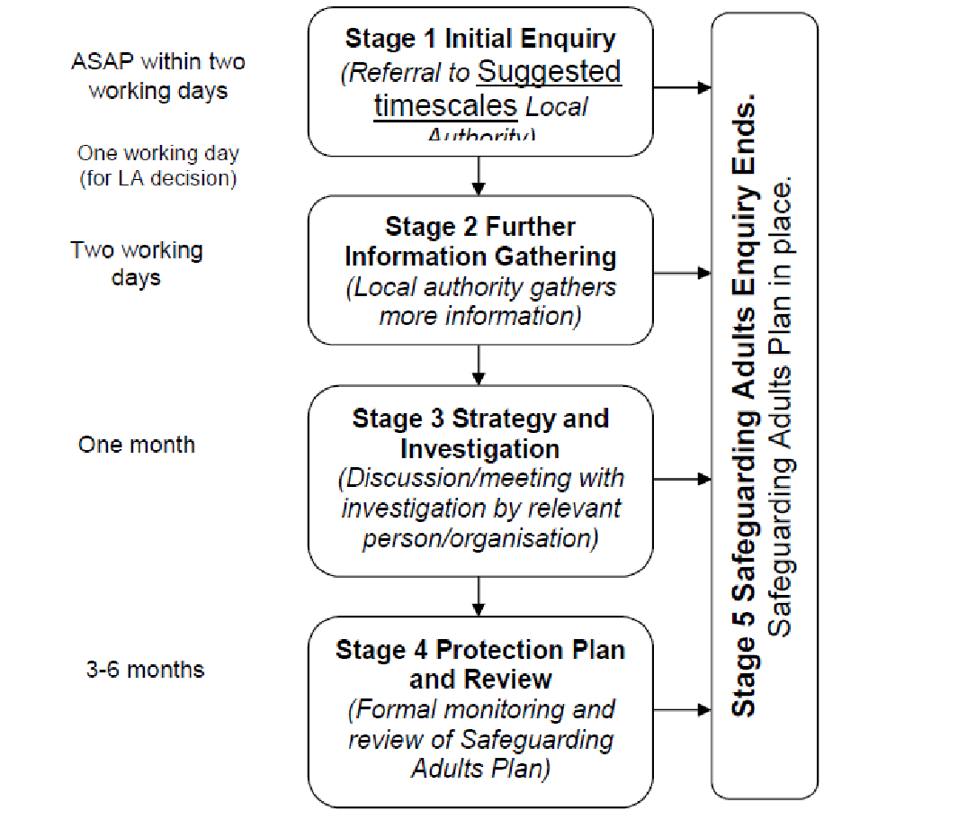

Safeguarding adults enquiries are:
- Driven by the desired outcomes of the adult or their representative;
- Multi-agency;
- Proportionate to the level of presenting harm/risk.

The Safeguarding Adults Enquiry can end at any stage, when it is felt that risks have been managed, and the desired outcomes of the adult (or their representative) have been met, as far as they possibly can be.

At every stage of the Safeguarding Adults Enquiry, risks will be assessed and a Safeguarding Adults Plan agreed.

