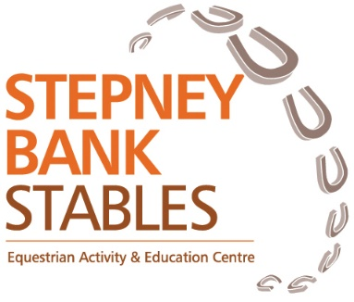

**Stepney Bank Stables**

**Equine Welfare Policy**

**Policy statement**

This policy aims to set out how we will support both the physical and mental wellbeing of the equines in our care.

We are committed to striving to do our very best for our equines; providing the highest standards of care and to continually monitoring, evaluating and improving management practices.

We expect that all staff, volunteers, visitors and riders will treat our horses and ponies respectfully with awareness and consideration. We will provide training and education to all who attend and through creative use of online content to spread awareness and understanding.

**Principals**

We will use the 5 domains of horse welfare as a framework.

**Physiological domains**

**Nutrition**

Horses will have access to good quality forage throughout the day and overnight.

We will feed small amounts at regular intervals from 7am until 8pm each day.

Small holed nets will be used to ensure horses have forage left throughout the night.

All horses will have fresh, clean water available at all times via automatic drinkers or buckets.

Enrichment activities will encourage natural foraging tendencies.

We will use low sugar, low starch feeds.

**Living Environment**

We will ensure all housing has adequate room to move around and lie down.

We will ensure housing is well ventilated.

We will ensure housing is cleaned out regularly throughout the day.

We will ensure sufficient bedding is provided.

We will enable ponies to live communally where feasible and safe to do so.

**Health and fitness**

We will not loan or purchase any horse under the age of 5 years old.

All horses will be examined by a vet before being added to the riding school licence and again at our annual inspection. Horses will receive regular farrier care and dental checks.

Saddles will be fitted by a Master Saddler and checked regularly.

All horses will have a weight limit which is strictly enforced

We will invest in the highest quality equipment which we can afford. Equipment will checked at each use.

Use of spurs is forbidden. Use of a whip is carefully managed by coaches. Abuse of the whip is not tolerated.

We will train staff and volunteers to monitor horses of signs of pain or distress and respond quickly to any behaviour changes. We work with a team of professionals including physiotherapists and massage therapists to keep our horses comfortable.

Horses and ponies are selected based on experience and temperament. After a reasonable settling in and schooling period, horses displaying signs that the environment is not acceptable for them, will be considered for resale.

**Behavioural domain**

**Interaction with other animals**

All horses will have access to turn out daily in either the indoor or outdoor arena with another horse whom they have a positive relationship with.

Horses can see other horses from their stable.

**Interaction with us**

Staff, volunteers, visitors and riders are trained to handle horses with consistent, agreed cues.

Riders will be taught to ride with empathy and consideration. Riders and horses will be appropriately matched

**Interaction with the environment**

Where possible horses are provided with room to explore their environment.

Enrichment activities are provided to reduce the risk of boredom.

All horses will have regular rest periods in the field. The frequency of these rest periods will be determined by factors such as health status, age, temperament.

We will provide varied activities including hand grazing, agility and target training to add variety and interest.

**Mental state**

All members of staff will receive ongoing training to develop their knowledge and skills. This will include regard for the horses mental and sensory abilities and their nature. This will be cascaded to volunteers, riders, young people and visitors.

**All of the above actions will support a positive mental state.**